OOP With Design Pattern

Student Name: Bichi Zhang

ID#: 1073838

Final Project

Due Date: 05/07/2019

Date of Submission: 05/06/2019

**Table of Contents**

UML Diagram………………………………………………………………………………………………………………………..3

Documented Source Code…………………………………………………………………………………………………….5

Screenshots ………………………………………………………………………………………………………………………..51

Things I learned……………………………………………………………………………………………………………………58

UML Diagram:

Creational: Signleton

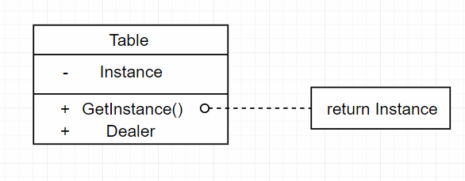

Factory

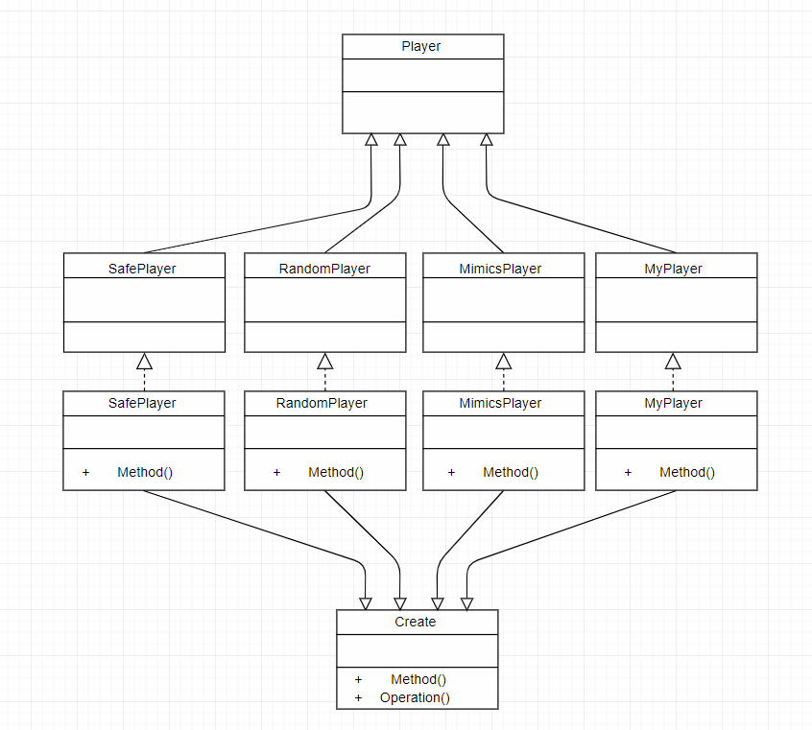

Structural: Façade

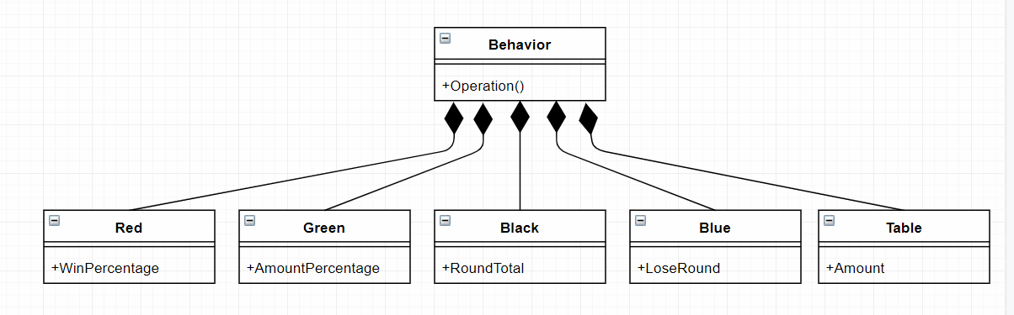

Documented Source Code:

File Name: deck.h

Author: Bichi Zhang

Date: 04/03/2019

Complier Used: C++ by Visual Studio 2017

Description: In this header file, I create a struct Card and a class Deck.

#ifndef POKER_DECK_H

#define POKER_DECK_H

#include <string>

#include <vector>

struct Card {

int color;

int value;

std::string to_string();

};

class Deck {

public:

Deck(int decks);

bool no_card_left() { return cards.size() == 0; }

Card hit_card();

private:

std::vector<Card> cards;

};

#endif //POKER_DECK_H

File Name: deck.cpp

Author: Bichi Zhang

Date: 04/04/2019

Complier Used: C++ by Visual Studio 2017

Description: In this cpp file, the deck will be initialized and shuffled.

#include "deck.h"

#include <algorithm>

std::string Card::to_string() {

std::string str = "";

if (color == 1) str = "Heart";

else if (color == 2) str = "Spade";

else if (color == 3) str = "Diamond";

else str = "Club";

std::string tp[13] = {"A","2","3","4","5","6","7","8","9","10","J","Q","K"};

str += tp[value - 1];

return str;

}

Deck::Deck(int decks) {

for (int i = 0;i < decks; ++i) {

for (int color = 1;color <= 4; ++color) {

for (int value = 1;value <= 13; ++value) {

Card card;

card.color = color;

card.value = value;

cards.push_back(card);

}

}

}

std::random_shuffle(cards.begin(), cards.end());

}

Card Deck::hit_card()

{

Card card = cards.back();

cards.pop_back();

return card;

}

File Name: dealer.h

Author: Bichi Zhang

Date: 04/04/2019

Complier Used: C++ by Visual Studio 2017

Description: In this header file, I create a class called Dealer with some function to run the project.

#ifndef POKER_DEALER_H

#define POKER_DEALER_H

#include <vector>

#include <iostream>

#include "deck.h"

class Dealer {

public:

Dealer(int id, int wp);

void add_card(Card c) {

hands.push_back(c);

}

void clear_card() {

hands.clear();

}

bool is_bust() {

int sum = get_hands_sum();

return (sum > 21);

}

bool is_stay() {

int sum = get_hands_sum();

return (sum >= 17);

}

void show_hands();

int get_hands_sum();

bool should_leave() {

return (win_count + lose_count) * 0.01 * win_percent > win_count;

}

void reset() {

win_count = lose_count = round_count = 0;

amount = 10000;

}

private:

int employee_id;

int round_count;

float amount;

int win_percent;

std::vector<Card> hands;

public:

int win_count;

int lose_count;

};

#endif //POKER_DEALER_H

File Name: dealer.cpp

Author: Bichi Zhang

Date: 04/05/2019

Complier Used: C++ by Visual Studio 2017

Description: In this cpp file, I write function to show hands of dealer and calculate sum of them.

#include "dealer.h"

Dealer::Dealer(int id, int wp): employee_id(id),

win_count(0),

lose_count(0),

round_count(0),

amount(1000),

win_percent(wp) {

}

void Dealer::show_hands() {

for (Card hand: hands) {

std::cout << hand.to_string() << ",";

}

}

int Dealer::get_hands_sum() {

int sum = 0;

for (Card hand: hands) {

if (hand.value >= 10) {

sum += 10;

} else if (hand.value == 1 && sum<11) {

sum += 11;

} else {

sum += hand.value;

}

}

return sum;

}

File Name: player.h

Author: Bichi Zhang

Date: 04/15/2019

Complier Used: C++ by Visual Studio 2017

Description: In this file, I create a class Player and divide it into 16 subclasses according to different strategy and tables.

#ifndef POKER_PLAYER_H

#define POKER_PLAYER_H

#include <iostream>

#include <cstdlib>

#include <vector>

#include "deck.h"

class Player {

public:

Player(int id): player_id(id) {

win = false;

win_round = 0;

lose_round = 0;

cont_lose_round = 0;

wait_begin_tik = -1;

assign_amount(3000);

loss_amount = 0;

win_amount = 0;

}

int get_player_id() const { return player_id; }

void add_card(Card c) {

hands.push_back(c);

}

void clear_card() {

hands.clear();

}

void add_amount(float a) {

amount += a;

win_amount += a;

}

void del_amount(float a) {

amount -= a;

lose_round += 1;

cont_lose_round += 1;

loss_amount += a;

}

bool is_bust() {

int sum = get_hands_sum();

return (sum > 21);

}

void assign_table(int tid) {

table_number = tid;

}

void assign_amount(int a) {

amount = a;

init_amount = a;

}

float get_amount() const { return amount; }

bool black_jack() {

int sum = get_hands_sum();

return hands.size() == 2 && sum == 21;

}

int get_hands_sum() const {

int sum = 0;

for (Card hand: hands) {

if (hand.value >= 10) {

sum += 10;

} else if (hand.value == 1&&sum<11) {

sum += 11;

} else {

sum += hand.value;

}

}

return sum;

}

void show_hands() {

for (Card hand: hands) {

std::cout << hand.to_string() << ",";

}

}

bool is_win() const { return win; }

void set_win(bool w) {

win = w;

win_round += 1;

cont_lose_round = 0;

}

int get_bet() { return bet_amount; }

virtual bool should_leave() = 0;

virtual void bet() = 0;

virtual bool play() = 0;

void reset() {

table_number = 0;

win_round = lose_round = 0;

}

void set_wait_begin_tik(int tik) {

wait_begin_tik = tik;

}

int get_wait_begin_tik() const { return wait_begin_tik; }

int all_round() const { return win_round + lose_round; }

virtual void report_done() = 0;

int loss_amount;

int win_amount;

protected:

int player_id;

int table_number;

int wait_begin_tik;

float amount;

float init_amount;

int bet_amount;

int cont_lose_round;

bool win;

std::vector<Card> hands;

int win_round;

int lose_round;

};

class RandomPlayer: public Player {

public:

RandomPlayer(int id): Player(id) {

}

bool play() {

//Uses his/her hunch to decide on a hit or stay

//random

return rand() % 2 == 1;

}

void bet() {}

bool should_leave() {return false;}

void report_done() {

std::cout << player_id << ", " << "RandomPlayer ";

if (win) {

std::cout << "won " << win_amount;

} else {

std::cout << "lost " << loss_amount;

}

std::cout << " on " << table_number << std::endl;

}

};

class SafePlayer: public Player {

public:

SafePlayer(int id): Player(id) {

}

bool play() {

//refuses to hit any hand that might bust

int sum = get_hands_sum();

if (21 - sum <= 11) {

return false;

}

return true;

}

void bet() {}

bool should_leave() {return false;}

void report_done() {

std::cout << player_id << ", " << "SafePlayer ";

if (win) {

std::cout << "won " << win_amount;

} else {

std::cout << "lost " << loss_amount;

}

std::cout << " on " << table_number << std::endl;

}

};

class MimicsDealer: public Player {

public:

MimicsDealer(int id): Player(id) {

}

bool play() {

//Hits all hands 16 or less and stays on hands that are 17 or more

int sum = get_hands_sum();

if (sum <= 16) {

return true;

}

return false;

}

void bet() {}

bool should_leave() {return false;}

void report_done() {

std::cout << player_id << ", " << "MimicsDealer ";

if (win) {

std::cout << "won " << win_amount;

} else {

std::cout << "lost " << loss_amount;

}

std::cout << " on " << table_number << std::endl;

}

};

class MyPlayer: public Player {

public:

MyPlayer(int id): Player(id) {

}

bool play() {

int sum = get_hands_sum();

if (sum >= 18) {

return false;

}

return true;

}

void bet() {}

bool should_leave() {return false;}

void report_done() {

std::cout << player_id << ", " << "MyPlayer ";

if (win) {

std::cout << "won " << win_amount;

} else {

std::cout << "lost " << loss_amount;

}

std::cout << " on " << table_number << std::endl;

}

};

class RandomRedPlayer: public RandomPlayer {

public:

RandomRedPlayer(int id): RandomPlayer(id) {

}

void bet() {

bet_amount = (rand() % 9 + 1) * 5;

}

bool should_leave() {

return (lose_round + win_round) * 0.6 < lose_round && (lose_round+win_round)>1;

}

void report_done() {

std::cout << player_id << ", " << "RandomRedPlayer ";

if (win) {

std::cout << "won " << win_amount;

} else {

std::cout << "lost " << loss_amount;

}

std::cout << " on " << table_number << std::endl;

}

};

class RandomGreenPlayer: public RandomPlayer {

public:

RandomGreenPlayer(int id): RandomPlayer(id) {

}

void bet() {

bet_amount = (rand() % 10) * 5 + 50;

}

bool should_leave() {

return init_amount * 0.1 >= amount;

}

void report_done() {

std::cout << player_id << ", " << "RandomGreenPlayer ";

if (win) {

std::cout << "won " << win_amount;

} else {

std::cout << "lost " << loss_amount;

}

std::cout << " on " << table_number << std::endl;

}

};

class RandomBluePlayer: public RandomPlayer {

public:

RandomBluePlayer(int id): RandomPlayer(id) {

}

void bet() {

bet_amount = (rand() % 40) * 10 + 100;

}

bool should_leave() {

return cont_lose_round == 3;

}

void report_done() {

std::cout << player_id << ", " << "RandomBluePlayer ";

if (win) {

std::cout << "won " << win_amount;

} else {

std::cout << "lost " << loss_amount;

}

std::cout << " on " << table_number << std::endl;

}

};

class RandomBlackPlayer: public RandomPlayer {

public:

RandomBlackPlayer(int id): RandomPlayer(id) {

}

void bet() {

bet_amount = (rand() % 6) * 100 + 500;

}

bool should_leave() {

return (lose_round + win_round) == 10;

}

void report_done() {

std::cout << player_id << ", " << "RandomBlackPlayer ";

if (win) {

std::cout << "won " << win_amount;

} else {

std::cout << "lost " << loss_amount;

}

std::cout << " on " << table_number << std::endl;

}

};

class SafeRedPlayer: public SafePlayer {

public:

SafeRedPlayer(int id): SafePlayer(id) {

}

void bet() {

bet_amount = (rand() % 9 + 1) * 5;

}

bool should_leave() {

return (lose_round + win_round) * 0.6 < lose_round && (lose_round + win_round)>1;

}

void report_done() {

std::cout << player_id << ", " << "SafeRedPlayer ";

if (win) {

std::cout << "won " << win_amount;

} else {

std::cout << "lost " << loss_amount;

}

std::cout << " on " << table_number << std::endl;

}

};

class SafeGreenPlayer: public SafePlayer {

public:

SafeGreenPlayer(int id): SafePlayer(id) {

}

void bet() {

bet_amount = (rand() % 10) * 5 + 50;

}

bool should_leave() {

return init_amount * 0.1 >= amount;

}

void report_done() {

std::cout << player_id << ", " << "SafeGreenPlayer ";

if (win) {

std::cout << "won " << win_amount;

} else {

std::cout << "lost " << loss_amount;

}

std::cout << " on " << table_number << std::endl;

}

};

class SafeBluePlayer: public SafePlayer {

public:

SafeBluePlayer(int id): SafePlayer(id) {

}

void bet() {

bet_amount = (rand() % 40) * 10 + 100;

}

bool should_leave() {

return cont_lose_round == 3;

}

void report_done() {

std::cout << player_id << ", " << "SafeBluePlayer ";

if (win) {

std::cout << "won " << win_amount;

} else {

std::cout << "lost " << loss_amount;

}

std::cout << " on " << table_number << std::endl;

}

};

class SafeBlackPlayer: public SafePlayer {

public:

SafeBlackPlayer(int id): SafePlayer(id) {

}

void bet() {

bet_amount = (rand() % 6) * 100 + 500;

}

bool should_leave() {

return (lose_round + win_round) == 10;

}

void report_done() {

std::cout << player_id << ", " << "SafeBlackPlayer ";

if (win) {

std::cout << "won " << win_amount;

} else {

std::cout << "lost " << loss_amount;

}

std::cout << " on " << table_number << std::endl;

}

};

class MimicsRedDealer: public MimicsDealer {

public:

MimicsRedDealer(int id): MimicsDealer(id) {

}

void bet() {

bet_amount = (rand() % 9 + 1) * 5;

}

bool should_leave() {

return (lose_round + win_round) * 0.6 < lose_round && (lose_round + win_round)>1;

}

void report_done() {

std::cout << player_id << ", " << "MimicsRedDealer ";

if (win) {

std::cout << "won " << win_amount;

} else {

std::cout << "lost " << loss_amount;

}

std::cout << " on " << table_number << std::endl;

}

};

class MimicsGreenDealer: public MimicsDealer {

public:

MimicsGreenDealer(int id): MimicsDealer(id) {

}

void bet() {

bet_amount = (rand() % 10) * 5 + 50;

}

bool should_leave() {

return init_amount * 0.1 >= amount;

}

void report_done() {

std::cout << player_id << ", " << "MimicsGreenDealer ";

if (win) {

std::cout << "won " << win_amount;

} else {

std::cout << "lost " << loss_amount;

}

std::cout << " on " << table_number << std::endl;

}

};

class MimicsBlueDealer: public MimicsDealer {

public:

MimicsBlueDealer(int id): MimicsDealer(id) {

}

void bet() {

bet_amount = (rand() % 40) * 10 + 100;

}

bool should_leave() {

return cont_lose_round == 3;

}

void report_done() {

std::cout << player_id << ", " << "MimicsBlueDealer ";

if (win) {

std::cout << "won " << win_amount;

} else {

std::cout << "lost " << loss_amount;

}

std::cout << " on " << table_number << std::endl;

}

};

class MimicsBlackDealer: public MimicsDealer {

public:

MimicsBlackDealer(int id): MimicsDealer(id) {

}

void bet() {

bet_amount = (rand() % 6) * 100 + 500;

}

bool should_leave() {

return (lose_round + win_round) == 10;

}

void report_done() {

std::cout << player_id << ", " << "MimicsBlackDealer ";

if (win) {

std::cout << "won " << win_amount;

} else {

std::cout << "lost " << loss_amount;

}

std::cout << " on " << table_number << std::endl;

}

};

class MyRedPlayer: public MyPlayer {

public:

MyRedPlayer(int id): MyPlayer(id) {

}

void bet() {

bet_amount = (rand() % 9 + 1) * 5;

}

bool should_leave() {

return (lose_round + win_round) * 0.6 < lose_round && (lose_round + win_round)>1;

}

void report_done() {

std::cout << player_id << ", " << "MyRedPlayer ";

if (win) {

std::cout << "won " << win_amount;

} else {

std::cout << "lost " << loss_amount;

}

std::cout << " on " << table_number << std::endl;

}

};

class MyGreenPlayer: public MyPlayer {

public:

MyGreenPlayer(int id): MyPlayer(id) {

}

void bet() {

bet_amount = (rand() % 10) * 5 + 50;

}

bool should_leave() {

return init_amount * 0.1 >= amount;

}

void report_done() {

std::cout << player_id << ", " << "MyGreenPlayer ";

if (win) {

std::cout << "won " << win_amount;

} else {

std::cout << "lost " << loss_amount;

}

std::cout << " on " << table_number << std::endl;

}

};

class MyBluePlayer: public MyPlayer {

public:

MyBluePlayer(int id): MyPlayer(id) {

}

void bet() {

bet_amount = (rand() % 40) * 10 + 100;

}

bool should_leave() {

return cont_lose_round == 3;

}

void report_done() {

std::cout << player_id << ", " << "MyBluePlayer ";

if (win) {

std::cout << "won " << win_amount;

} else {

std::cout << "lost " << loss_amount;

}

std::cout << " on " << table_number << std::endl;

}

};

class MyBlackPlayer: public MyPlayer {

public:

MyBlackPlayer(int id): MyPlayer(id) {

}

void bet() {

bet_amount = (rand() % 6) * 100 + 500;

}

bool should_leave() {

return (lose_round + win_round) == 10;

}

void report_done() {

std::cout << player_id << ", " << "MyBlackPlayer ";

if (win) {

std::cout << "won " << win_amount;

} else {

std::cout << "lost " << loss_amount;

}

std::cout << " on " << table_number << std::endl;

}

};

#endif //POKER_PLAYER_H

File Name: table.h

Author: Bichi Zhang

Date: 04/06/2019

Complier Used: C++ by Visual Studio 2017

Description: In this header file, I create a class BlackjackTable to simulate a game on one table.

#ifndef POKER_TABLE_H

#define POKER_TABLE_H

#include "dealer.h"

#include "player.h"

#include <vector>

class BlackjackTable {

public:

BlackjackTable(int id, int deck_count, int cap);

void assign_dealer(Dealer d) {

dealer = d;

}

bool can_play() {

return players.size() != 0;

}

Dealer& get_dealer() { return dealer; }

bool has_position() {

return player_count < capacity;

}

void add_player(Player* player);

void bet();

void dealing();

void playing();

void result();

std::vector<Player*> clear_player();

public:

int table_number;

private:

Deck deck;

Dealer dealer;

std::vector<Player*> players;

int player_count;

int capacity;

};

#endif //POKER_TABLE_H

File Name: table.cpp

Author: Bichi Zhang

Date: 04/17/2019

Complier Used: C++ by Visual Studio 2017

Description: In this cpp file, give the specific code to deal with a game on one table.

#include "table.h"

#include "stat_keeper.h"

BlackjackTable::BlackjackTable(int id, int deck_count, int cap):

table_number(id),

dealer(-1, 0),

deck(deck_count),

player_count(0),

capacity(cap)

{

}

void BlackjackTable::add_player(Player* player) {

player_count += 1;

players.push_back(player);

player->assign_table(table_number);

}

void BlackjackTable::bet() {

dealer.clear_card();

for (Player* player: players) {

player->clear_card();

player->bet();

std::cout << "player " << player->get_player_id() << " bet " << player->get_bet() << std::endl;

}

}

void BlackjackTable::dealing() {

for (int i = 0;i < 2; ++i) {

for (Player* player: players) {

player->add_card(deck.hit_card());

}

}

dealer.add_card(deck.hit_card());

}

void BlackjackTable::playing() {

total_table_players += players.size();

table_play += 1;

dealer.add_card(deck.hit_card());

bool win = false;

for (Player* player: players) {

if (player->black_jack()) {

player->set_win(true);

if (dealer.get_hands_sum() != 21) {

player->add_amount(player->get_bet() * 1.5);

}

win = true;

}

}

if (win) {

dealer.lose_count += 1;

return ;

}

bool cont = false;

while (!cont) {

cont = false;

for (Player* player: players) {

for (int i = 0; i < 5; i++)

{

if (!player->is_bust() && player->play()) {

player->add_card(deck.hit_card());

cont = true;

}

}

}

for (int i = 0; i < 5; i++)

{

if (!dealer.is_stay()) {

cont = true;

dealer.add_card(deck.hit_card());

}

}

if (dealer.is_bust()) {

dealer.lose_count += 1;

for (Player* player: players) {

player->set_win(true);

player->add_amount(player->get_bet());

}

return ;

}

}

bool dealer_lose = true;

for (Player* player: players) {

if (!player->is_bust() &&

player->get_hands_sum() > dealer.get_hands_sum()) {

player->set_win(true);

player->add_amount(player->get_bet());

}

else if(!player->is_bust() &&

player->get_hands_sum() < dealer.get_hands_sum()) {

player->del_amount(player->get_bet());

dealer_lose = false;

}

else if (player->is_bust())

{

player->del_amount(player->get_bet());

}

else {

dealer_lose = false;

}

}

if (dealer_lose) {

dealer.lose_count += 1;

} else {

dealer.win_count += 1;

}

}

void BlackjackTable::result() {

std::cout << "Dealer: ";

dealer.show_hands();

std::cout << " sum: " << dealer.get_hands_sum() << std::endl;

dealer.clear_card();

for (Player* player: players) {

std::cout << "Player " << player->get_player_id() << ": ";

player->show_hands();

std::cout << " ";

std::cout << "sum: " << player->get_hands_sum() << " ";

std::cout << "bet amount: " << player->get_bet() << std::endl;

}

for (Player* player: players) {

std::cout << "Player " << player->get_player_id() << " ";

if (player->is_win()) {

std::cout << "wins, ";

} else {

std::cout << "loses, ";

}

std::cout << "balance: " << player->get_amount() << std::endl;

player->clear_card();

}

}

std::vector<Player*> BlackjackTable::clear_player() {

std::vector<Player*> leave;

std::vector<Player*> stay;

for (Player* player: players) {

if (player->should_leave()) {

leave.push_back(player);

} else {

stay.push_back(player);

}

}

players.clear();

for (Player* player: stay) {

players.push_back(player);

}

player_count = players.size();

return leave;

}

File Name: game.h

Author: Bichi Zhang

Date: 04/14/2019

Complier Used: C++ by Visual Studio 2017

Description: In this header file, I create a class called Game aimed to control the system.

#ifndef POKER_GAME_H

#define POKER_GAME_H

#ifndef POKER_GAME_H

#define POKER_GAME_H

#include <vector>

#include <list>

#include "deck.h"

#include "dealer.h"

#include "table.h"

class Game {

public:

Game(int table_count, int player_count, int deck_count, int number_of_deals,

int win_percentage);

void add_player(Player* player, int tiktok);

std::list<Player*> total_players;

std::vector<BlackjackTable> tables;

std::list<Dealer> dealer_queue;

std::list<Player*> player_queue;

};

#endif //POKER_GAME_H

File Name: game.cpp

Author: Bichi Zhang

Date: 04/05/2019

Complier Used: C++ by Visual Studio 2017

Description: In this cpp file, give the specific function code to simulate the system controller.

#include "game.h"

#include "stat_keeper.h"

Game::Game(int table_count, int player_count, int deck_count, int number_of_deals,

int win_percentage) {

for (int i = 0;i < table_count; ++i) {

BlackjackTable table(i, deck_count, player_count);

tables.push_back(table);

}

for (int i = 0;i < number_of_deals; ++i) {

Dealer dealer(i, win_percentage);

dealer_queue.push_back(dealer);

}

for (std::vector<BlackjackTable>::iterator it = tables.begin();it != tables.end(); ++it) {

Dealer dealer = dealer_queue.front();

dealer_queue.pop_front();

it->assign_dealer(dealer);

}

}

void Game::add_player(Player* player, int tiktok) {

total_players.push_back(player);

for (std::vector<BlackjackTable>::iterator it = tables.begin();it != tables.end(); ++it) {

if (it->has_position()) {

it->add_player(player);

std::cout << "player " << player->get_player_id() << " enter table " << it->table_number << std::endl;

return ;

}

}

std::cout << "player " << player->get_player_id() << " wait in the queue" << std::endl;

player->set_wait_begin_tik(tiktok);

player_queue.push_back(player);}

File Name: stat_keeper.h

Author: Bichi Zhang

Date: 04/07/2019

Complier Used: C++ by Visual Studio 2017

Description: In this header file, I write a struct called stat_keeper to keep the statistics.

#ifndef POKER_STAT_KEEPER_H

#define POKER_STAT_KEEPER_H

extern int total_number_of_games;

extern int total_table_players;

extern int table_play;

#endif //POKER_STAT_KEEPER_H

File Name: partition.h

Author: Bichi Zhang

Date: 04/16/2019

Complier Used: C++ by Visual Studio 2017

Description: In this header file, I write a class called partition to access the game table only if required.

#ifndef __PARTITION_H__

#define __PARTITION_H__

#include "table.h"

class Partition {

BlackjackTable* gtp;

Partition *nextp;

public:

Partition(BlackjackTable* g, Partition *next): gtp(g), nextp(next) {}

BlackjackTable* get_gtp() const { return gtp; }

Partition * get_next() const { return nextp; }

};

#endif

File Name: timewheel.h

Author: Bichi Zhang

Date: 04/17/2019

Complier Used: C++ by Visual Studio 2017

Description: In this header file, I write a class called timingwheel and use some functions to work as a clock as well as a temporary storage service.

#ifndef __TIMINGWHEEL_H__

#define __TIMINGWHEEL_H__

#define max_delay 100

#include "partition.h"

#include "game.h"

class TimingWheel

{

Partition * slot[max_delay + 1];

public:

int current_slot;

Game* game_ptr;

public:

TimingWheel();

void insert(int play_time, BlackjackTable* p1);

void schedule();

void clear_curr_slot();

};

#endif

File Name: timewheel.cpp

Author: Bichi Zhang

Date: 04/19/2019

Complier Used: C++ by Visual Studio 2017

Description: In this cpp file, I give the specific function code to run the timewheel.

#include "timingwheel.h"

#include "stat_keeper.h"

TimingWheel::TimingWheel(): current_slot(0)

{

for (int i = 0;i < max_delay + 1; ++i)

{

slot[i] = NULL;

}

}

void TimingWheel::insert(int play_time, BlackjackTable* p1)

{

int position = play_time + current_slot;

position %= (max_delay + 1);

Partition* partition = new Partition(p1, slot[position]);

slot[position] = partition;

}

void TimingWheel::schedule()

{

Partition* curr = slot[current_slot];

bool has_empty = true;

while (!game_ptr->player_queue.empty() && has_empty) {

has_empty = false;

while (curr)

{

if (curr->get_gtp()->has_position()) {

has_empty = true;

if (game_ptr->player_queue.empty()) {

break;

}

Player* player = game_ptr->player_queue.front();

game_ptr->player_queue.pop_front();

curr->get_gtp()->add_player(player);

std::cout << "player " << player->get_player_id() << " enter table " << curr->get_gtp()->table_number << std::endl;

}

curr = curr->get_next();

}

}

curr = slot[current_slot];

while (curr)

{

std::cout << "[table-" << curr->get_gtp()->table_number << "]" << std::endl;

if (!curr->get_gtp()->can_play()) {

std::cout << "no player on this table" << std::endl;

} else {

total_number_of_games += 1;

curr->get_gtp()->bet();

curr->get_gtp()->dealing();

curr->get_gtp()->playing();

curr->get_gtp()->result();

Dealer dealer = curr->get_gtp()->get_dealer();

if (dealer.should_leave() && !game_ptr->dealer_queue.empty()) {

dealer.reset();

game_ptr->dealer_queue.push_back(dealer);

dealer = game_ptr->dealer_queue.front();

game_ptr->dealer_queue.pop_front();

curr->get_gtp()->assign_dealer(dealer);

}

std::vector<Player*> leave_players = curr->get_gtp()->clear_player();

for (Player* player: leave_players) {

std::cout << "player " << player->get_player_id() << " leave table " << curr->get_gtp()->table_number << std::endl;

player->report_done();

player->reset();

//player_queue.push_back(player);

}

}

curr = curr->get_next();

}

}

void TimingWheel::clear_curr_slot()

{

Partition* curr = slot[current_slot];

Partition* target;

while (curr)

{

target = curr;

curr = curr->get_next();

delete target;

}

}

File Name: main.cpp

Author: Bichi Zhang

Date: 04/25/2019

Complier Used: C++ by Visual Studio 2017

Description: This cpp file reads the input file and generates traffic according to it and then output the betting stage, dealing stage, result stage and the statistics about the game.

#include <iostream>

#include <ctime>

#include <cstdlib>

#include <fstream>

#include <Windows.h>

#include "player.h"

#include "game.h"

#include "stat_keeper.h"

#include "timingwheel.h"

static int player_id_generator = 0;

int total_number_of_players = 0;

int total_number_of_games = 0;

int total_table_players = 0;

int table_play = 0;

Player* player_generate(int* p, int* r, int* md, int* s, int* c) {

int type = std::rand() % 100;

if (type <= p[0]) {

if (type <= r[0]) {

return new RandomRedPlayer(++player_id_generator);

} else if (type <= r[0] + r[1]) {

return new RandomGreenPlayer(++player_id_generator);

} else if (type <= r[0] + r[1] + r[2]) {

return new RandomBluePlayer(++player_id_generator);

} else {

return new RandomBlackPlayer(++player_id_generator);

}

} else if (type <= p[0] + p[1]) {

if (type <= md[0]) {

return new MimicsRedDealer(++player_id_generator);

} else if (type <= md[0] + md[1]) {

return new MimicsGreenDealer(++player_id_generator);

} else if (type <= md[0] + md[1] + md[2]) {

return new MimicsBlueDealer(++player_id_generator);

} else {

return new MimicsBlackDealer(++player_id_generator);

}

} else if (type <= p[0] + p[1] + p[2]) {

if (type <= s[0]) {

return new SafeGreenPlayer(++player_id_generator);

} else if (type <= s[0] + s[1]) {

return new SafeGreenPlayer(++player_id_generator);

} else if (type <= s[0] + s[1] + s[2]) {

return new SafeBluePlayer(++player_id_generator);

} else {

return new SafeBlackPlayer(++player_id_generator);

}

} else {

if (type <= c[0]) {

return new MyRedPlayer(++player_id_generator);

} else if (type <= c[0] + c[1]) {

return new MyGreenPlayer(++player_id_generator);

} else if (type <= c[0] + c[1] + c[2]) {

return new MyBluePlayer(++player_id_generator);

} else {

return new MyBlackPlayer(++player_id_generator);

}

}

}

int tiktok;

int table_count;

int player_count_low, player_count_high;

int deck_count_low, deck_count_high;

int number_of_deals, salary, win_percentage;

int p[4];

int r[4], md[4], s[4], c[4];

float enter_percent;

int number_of_init_players;

void initialize(int argc, char** argv) {

tiktok = std::atoi(argv[1]);

//std::cout << "enter time";

//std::cin >> tiktok;

unsigned seed = unsigned ( std::time(0) );

//std::cout << "Seed is " << seed << std::endl;

std::srand ( seed );

std::ifstream ifs("input.txt", std::ifstream::in);

ifs >> table_count;

ifs >> player_count_low >> player_count_high >> deck_count_low >> deck_count_high;

int threshold1, threshold2, threshold3, threshold4;

ifs >> threshold1 >> threshold2 >> threshold3 >> threshold4;

ifs >> number_of_deals >> salary >> win_percentage;

int miss;

ifs >> miss >> miss;

ifs >> number_of_init_players;

ifs >> p[0] >> p[1] >> p[2] >> p[3];

std::string misss;

ifs >> misss >> r[0] >> r[1] >> r[2] >> r[3];

ifs >> misss >> md[0] >> md[1] >> md[2] >> md[3];

ifs >> misss >> s[0] >> s[1] >> s[2] >> s[3];

ifs >> misss >> c[0] >> c[1] >> c[2] >> c[3];

ifs >> enter_percent;

ifs.close();

}

Game* game_ptr;

void print_status() {

std::cout << "Duration of simulation: " << tiktok << std::endl;

std::cout << "Total number of tables: " << table_count << std::endl;

//todo the total money of the casino before and after the simulation

//todo Dealer-wise performance in terms of win and loss percentage

std::cout << "Total number of players: " << total_number_of_players << std::endl;

double as = table_play?(total_table_players * 1.0 / table_play):0;

std::cout << "Average number of players per table: " << as << std::endl;

float rounds = 0;

for (Player* player: game_ptr->total_players) {

rounds += player->all_round();

}

std::cout << "Average playing rounds of each player: " << rounds * 1.0 / total_number_of_players << std::endl;

float max_win_amount = 0, max_lose_amount = 0;

for (Player* player: game_ptr->total_players) {

if (player->win_amount > max_win_amount)

max_win_amount = player->win_amount;

if (player->loss_amount > max_lose_amount)

max_lose_amount = player->loss_amount;

}

std::cout << "Maximum player win amount: " << max_win_amount << std::endl;

std::cout << "Maximum player loss amount: " << max_lose_amount << std::endl;

std::cout << "Total number of games played: " << total_number_of_games << std::endl;

//todo Level-wise number of games

//todo Number of times the refill cash event was generated

}

int main(int argc, char** argv) {

initialize(argc, argv);

int player_count = (std::rand() % (player_count_high - player_count_low + 1)) + player_count_low;

int deck_count = (std::rand() % (deck_count_high - deck_count_low + 1)) + deck_count_low;

game_ptr = new Game(table_count, player_count, deck_count, number_of_deals, win_percentage);

for (int i = 0;i < number_of_init_players; ++i) {

game_ptr->add_player(player_generate(p, r, md, s, c), 0);

}

total_number_of_players += number_of_init_players;

TimingWheel wheel;

wheel.game_ptr = game_ptr;

for (auto it = game_ptr->tables.begin();it != game_ptr->tables.end(); ++it) {

wheel.insert(1, &(*it));

}

for (int i = 1;i <= tiktok; ++i) {

//simulate

wheel.schedule();

wheel.clear_curr_slot();

for (auto it = game_ptr->tables.begin();it != game_ptr->tables.end(); ++it) {

wheel.insert(1, &(*it));

}

wheel.current_slot = (wheel.current_slot + 1) % (max_delay + 1);

Sleep(1);

if (std::rand() % 100 < enter_percent * 100) {

//add new player

total_number_of_players += 1;

game_ptr->add_player(player_generate(p, r, md, s, c), i);

}

}

print_status();

return 0;

}

Screenshot:

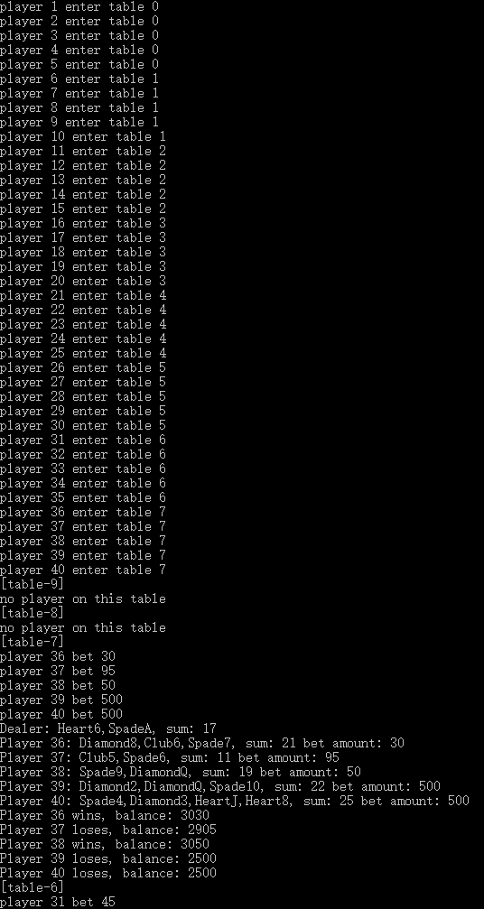

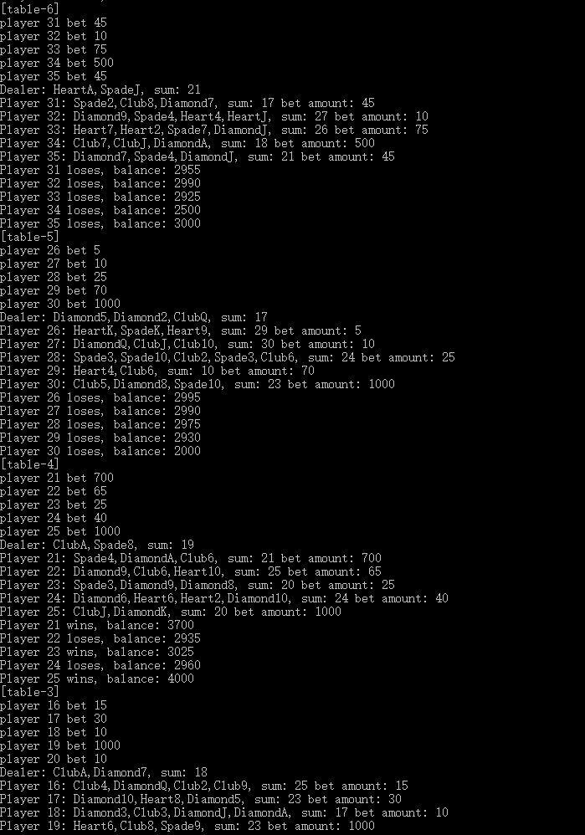

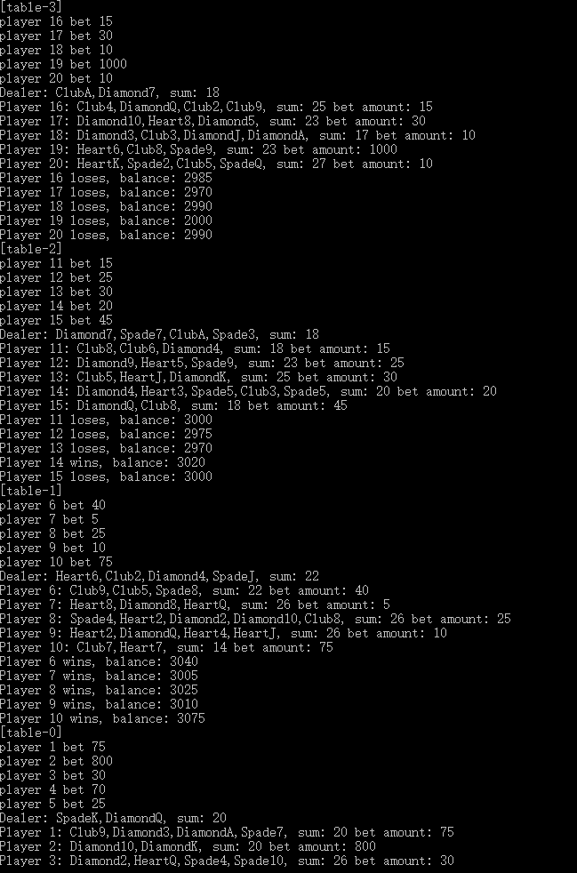

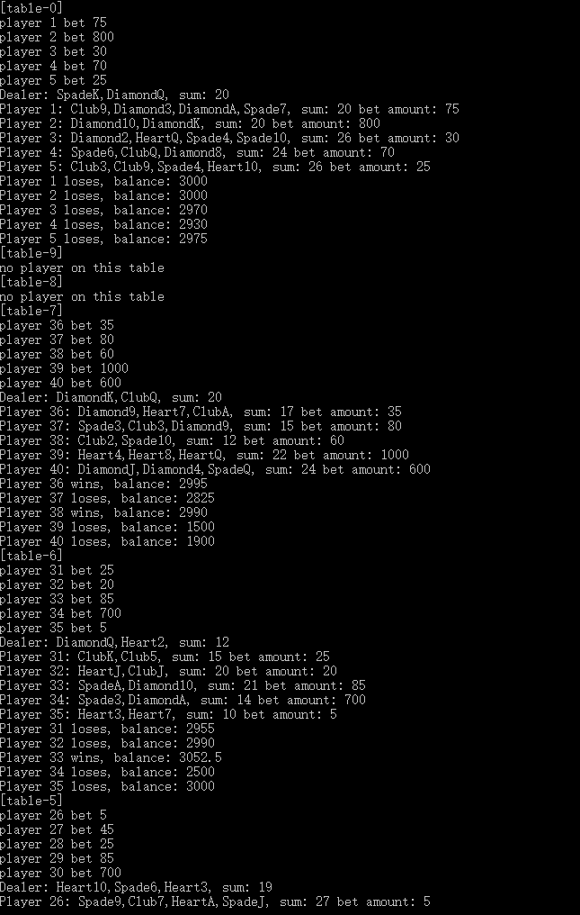

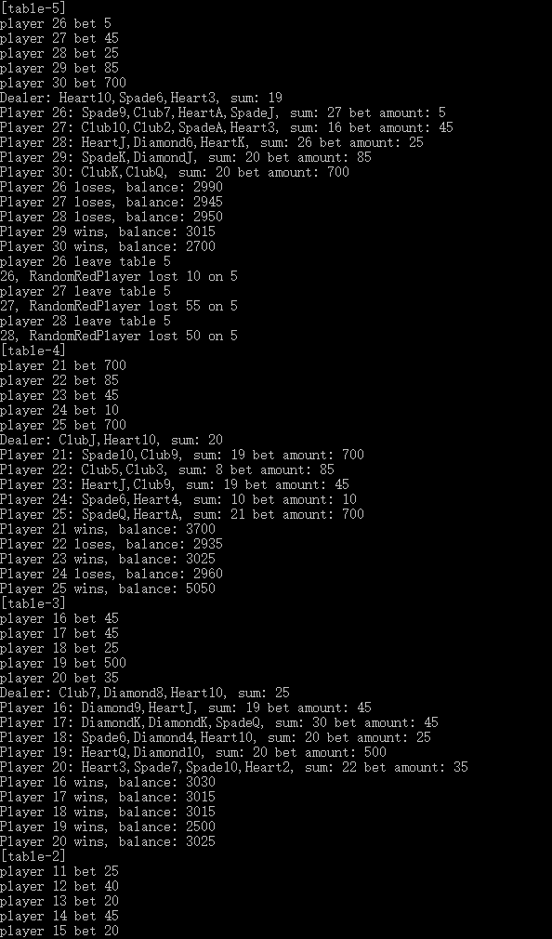 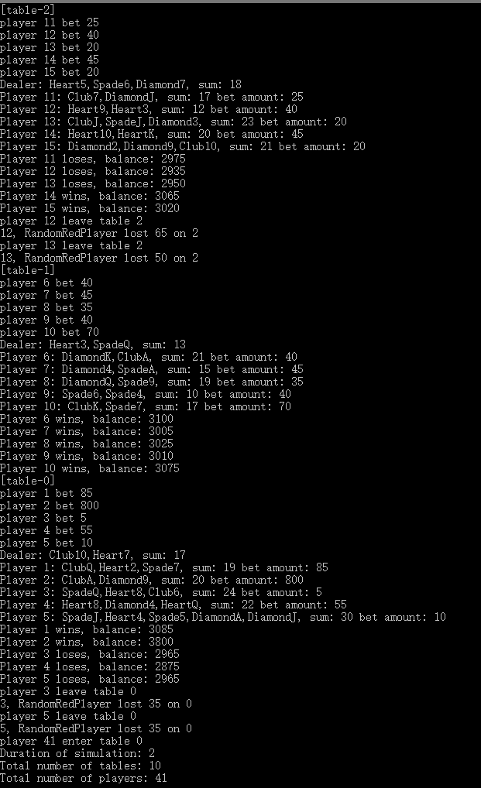 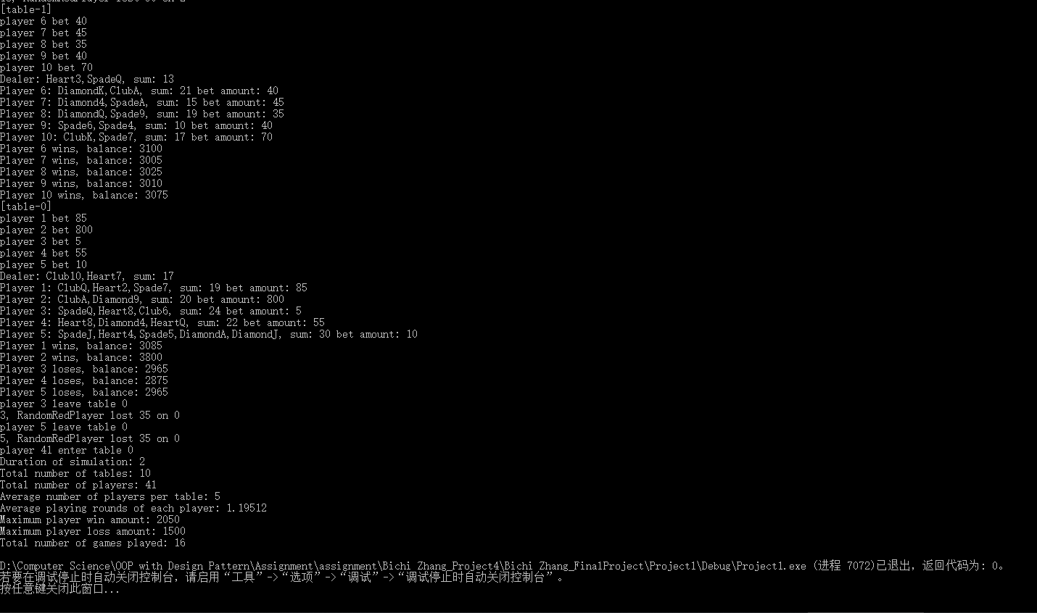

Things I learned:

This project is quite a huge project for this course especially for a group with only one person in it. But I did improve my ability through this project. In this project, I combined the knowledge I had learned before, especially for the polymorphic call and in the project I also make a mistake: I forget to use dynamic memory allocation, which will cause a memory leak. I also need to add some information to output for reader to get more information.